Chinese Military Tanker Uses 3D Printing for Replacement Parts
3DPrinting industry.com, By Davide Sher On Fri, August 14, 2015
On demand 3D printing is taking off in some of the world’s most advanced military forces, including the US and the UK military. Now, the Chinese Army is introducing the technology, as well, by looking at the more practical side of its implementation. So, when a military oil (or gasoline?) tanker truck was damaged in Chengdu during an exercise, and the replacement parts were not readily available, the team resorted to 3D printing.
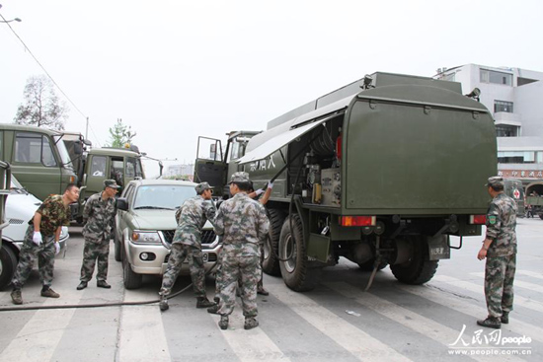
The damaged parts were the trucks couplings, a component of the oil pumping system. These are considered non-consumable parts and are, thus, not kept as inventory in the emergency depot. To enable repair of the unit, the support team simply designed the necessary part and 3D printed it.
A journalist from the local CRI Online news portal reported that officer Dong Kaiyi rapidly created the three-dimensional model of the necessary component in a specific software program, while officer Liu Jun was charged with loading the polymer material into the 3D printer
Strangely enough the report states that the machine used a powder polymer material and then proceeded to form the part by bonding together the powder particles layer by layer, thus effectively describing a binder jetting technology. However, the only widely available binder jetting 3D printer that uses plastic at this time is 3D Systems expensive ProJet 4500. The Chinese military may have acquired one from 3DS. However, weighing in at well above 150 Kg, it would seem like a difficult system to carry on the battlefield. It is possible that they have developed their own version of a portable plastic binder jetting system or that the journalist (or Google’s translator) just got mixed up with a more standard FFF system.
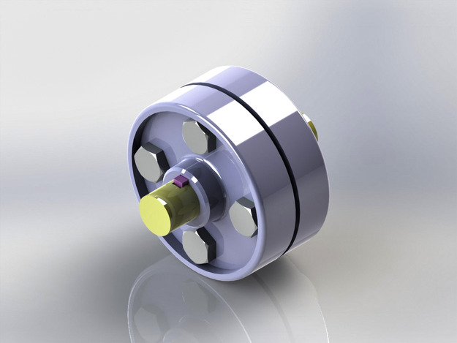
The Joint Logistics Department of the Military Leadership told reporters that, in warfare on mountainous terrains, only a very limited quantity of parts can be carried along. Now, that the effectiveness of 3D printed parts has been demonstrated, it will be possible to simply carry along the virtual 3D models of gears, ratchets, reels, shafts and other spare parts.
Following this event, setting a precedent, a “parts manufacturing workshop” will be established in order to promote the use of 3D printing technology for maintenance of all logistical equipment. The coupling proved fully functional and the tanker truck returned to normal operation.
Dong Kaiyi was very satisfied with the achievement, and especially with doing away with all the transport, waiting time and tools necessary to obtain replacement parts in the traditional way. It may have been just a coupling but it may mark a significant step forward for the Chinese defense forces and anyone involved in missions in remote locations.

