2020 AM Workshop Virtual – Survey Results

Question One – Name and/or Organization? (optional) – Not included, available upon request.

Question Two – How likely is it that you would attend an AM Workshop again in the future?
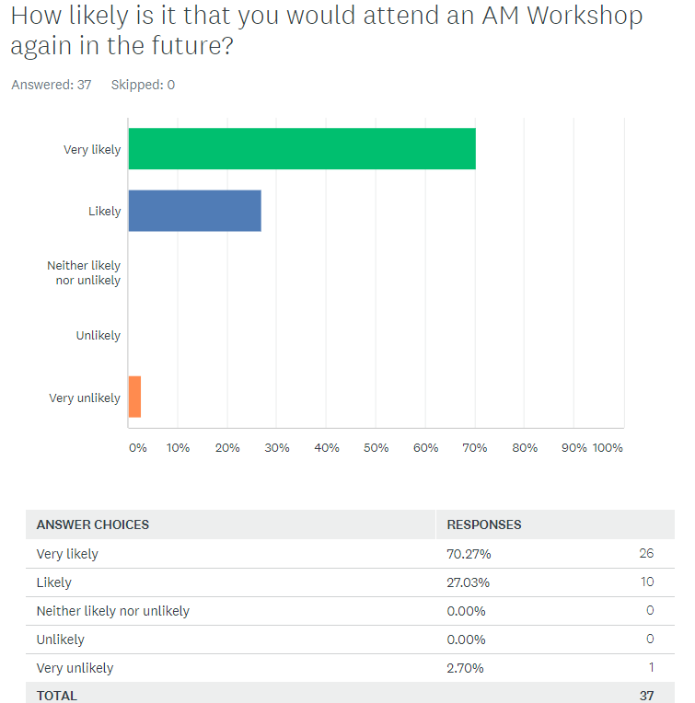

Question Three – Overall, how would you rate the 2020 AM Workshop virtual event?
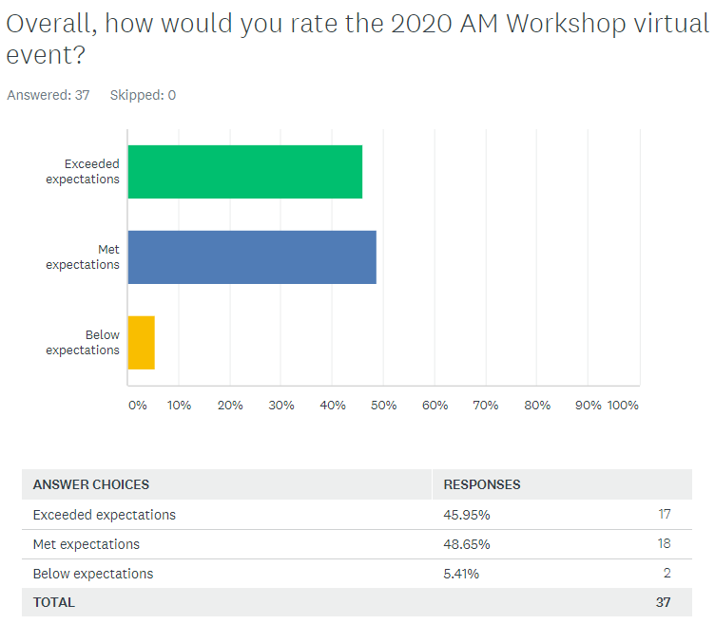
Question Four – What did you like about the event?
- Topics Selected. WG member participation.
- Participation.
- Rolled up sleeves and actually developed work product. Didn't just talk about it. Leveraged technology well, proved you can get results without having to travel.
- Given the disruption of COVID -19 I thought the networking, tele-connecting worked well.
- Even though it was virtual we still met the goals and objectives of the workshop.
- A lot of good information, too bad could only participate in one area.
- Collaborative working with AM experts within DoD and Industry.
- Overall, I thought it was run well.
- Valuable opinions of participants.
- Interaction with fellow community members working toward a common goal.
- Ability to meet in small effective groups.
- Virtual event maintained general Working Group Conops.
- Good to see overview of what each DoD organization was doing.
- Hearing the dialog between industry and DoD. Helped identify the similarities and differences between approaches.
- Engaging with former AM teammates. Continuing to move the ball forward. Please tell me how I can help get these things signed & published!
- The large gatherings were handled well, and the working groups were small enough to be able to focus on the tasks at hand.
- I enjoyed the interactive polls! It was an extremely effective and fun way to gather the groups thoughts in the virtual conference environment without going "around the room".
- I liked that everyone came together to view the results of all teams.
- Having a virtual event allowed me to participate; I would not typically have attended in-person. I was delighted to see active participation from both industry and government folks, whom I found to be very knowledgeable, thoughtful, and passionate.
- Very well managed, given the challenges of remote connectivity with such a large group.
- Lots of interesting content; a work-in-progress feel. Especially engaging presentations from Vicky Pilliteri, Mark Forged, Michael Mylrea.
- Great conversation and discussions on key AM topics.
- Collaborative effort to contribute into definition and standardization.
- Very well organized.
- Informative and was able to re-connect with colleagues.
- We were able to overcome virtual environment constraints.
- Good information on what has been happening. Interesting to see the commentary from the team.
- Valuable discussion
- There was more engagement than expected.
- Interactive, collaborative, and productive.
- Opportunity for DoD, Academia, and Industry to cross pollinate.
- I always like these events.
- The ability for industry, academia, and government to work together unimpeded by bureaucracy.

Question Five – What changes would you like to see in future events?
- Hopefully have a live face-to-face event again! If virtual though, schedule half-days. A full day is exhausting!
- Follow up communication.
- Improve the technology (some issues getting connected initially.)
- DLA had two workstreams, one per day and it seemed to work well, so maybe keep it this way in the future.
- There were some minor sound, access issues.
- More time to collaborate with other working groups on cross-over topics.
- More information sooner for the 'homework' to be done ahead of the event. We received the 'homework' on Friday before the event (the following Tuesday) - not enough time to read through the materials and bring a fully fleshed out response to the team.
- Breakout calls were a bit difficult to participate in; maybe a video conference could have helped for smaller breakout groups?
- I sure hope we can meet in person in the future. The virtual tool worked pretty well.
- Face to face is better....hope we can get back there again next year. Need to ensure that our collaborative virtual venue is checked out prior to the start of the event.
- Meeting in person.
- Zoom evening event could have working group component during day.
- I'd like to see more information and overview of AM specific issues with current implementation, rather than broad fact finding.
- Having a bit more time to have open dialog about the questions/topics presented during the breakout sessions. Having overviews of what was going on was helpful but think that took away from the insights from conversations.
- Doing this virtually, is extremely challenging, it’s unfortunate we didn't really have a choice in the matter. I know it doesn't bring out the full creativity and thought power of the group that we bring together.
- Being in person.
- For participants that have not taken part in workshops before it was hard to understand how to start and what has happened before. It would be good to have a short introduction of the purpose and some general information about the DoD and AM initiatives. this will set the framework for participants that have not participated before and are not part of the DoD.
- Given the speed at which the industry is changing, it seems more frequent updates would help with iterating quicker on the results of the workshops in terms of progress. This could be a quarterly event.
- Hopefully next year it would be possible to get back to the in-person format.
- For virtual deployments, may need to be more, shorter days for people on west coast time schedules.
- More input from the Industry participants/vendors, who could share the most cutting edge and innovative technologies, as well as, commercial case studies, which will help the DoD not to "reinvent the wheel"...
- I thought that it was really handled well - just a little confusion from time to time as to what URL to use and what number to dial. I would prefer to use the web-based platform for video AND audio instead of dialing in.
- Enhanced targeted engagement from members.
- More interactive tools.
- An understanding of what to make of the outcomes and how they might apply.
- Perhaps not using Adobe Connect, as it is harder to access for some.
- This was my first time. I was not forewarned of the continuity of sessions, and the amount of engagement - otherwise I would have dedicated additional time to attend more of the event. If possible, I recommend better communication of the format and level of engagement.
- More advance information regarding project scope and time investment required for the various breakout groups. I didn't balance priorities and clear schedules adequately in advance.
- None at this time.
- The control of the audio during the sessions was purely beyond acceptable. If anything, this would be the reason I would not attend another session. Additionally, this type of work should be engaged with the individuals before the actual sessions to ensure sessions do not get overran with personalities that are more aggressive than others. We lost a tremendous opportunity to make a product great instead of so-so.
- I think that the virtual aspect was good however I think it would be better to have collaboration tools that can be used in person or virtually that allow the information to be saved and distributed easily after the event.

Question Six – Was the event engaging?
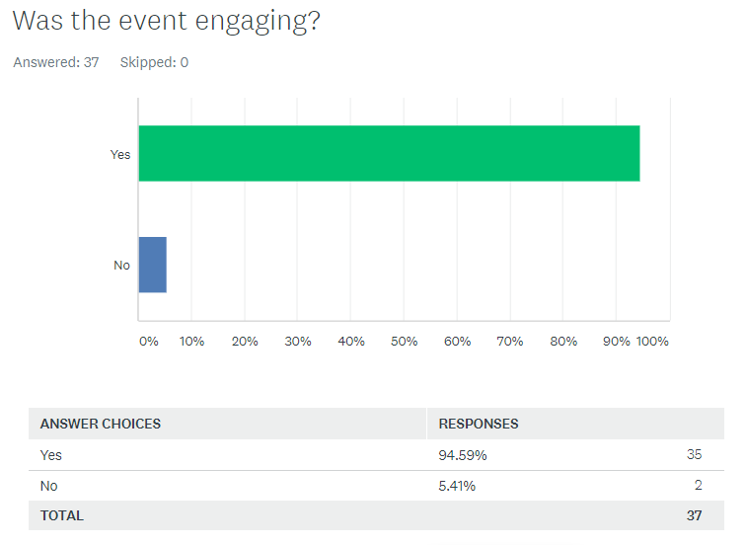

Question Seven – Prior to the event, how much of the information that you needed did you get?
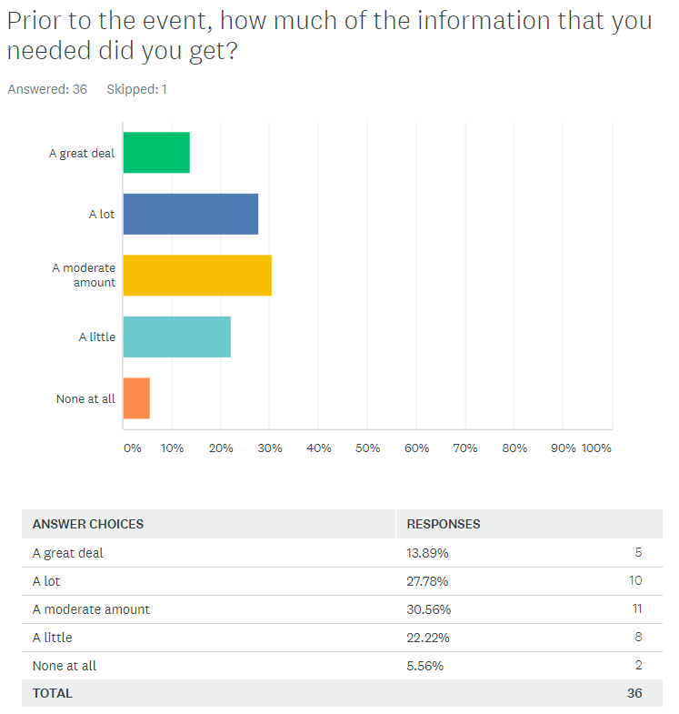

Question Eight – Was the event length too long, too short or about right?
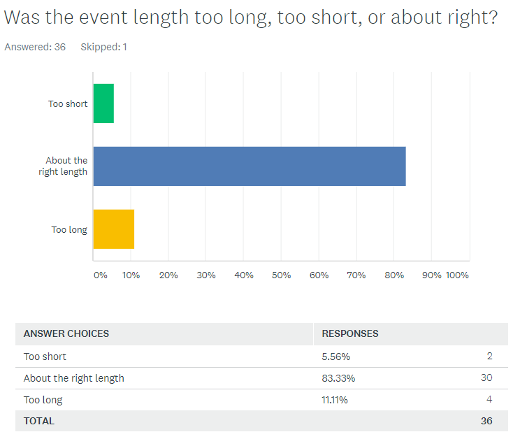

Question Nine – I felt that my time spent dedicated to the AM Workshop was informative and valuable.
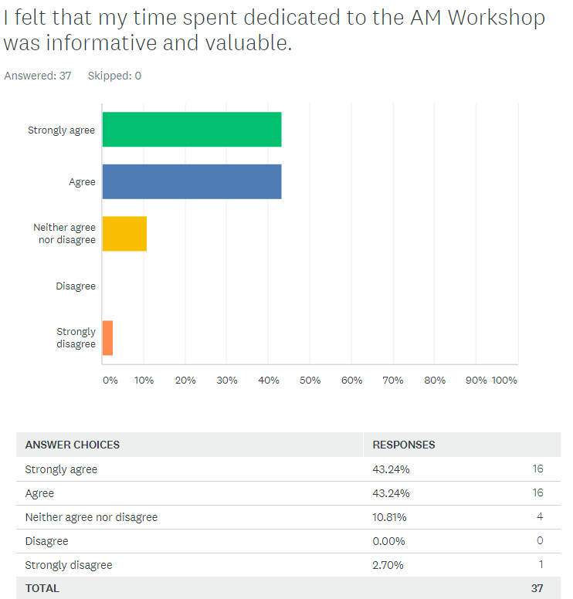

Question Ten – What topics would you like to have included in the next workshop?
- AM in an Expeditionary Environment; AM at the DOD Enterprise Level: Integrating the Services/Agencies.
- In-situ NDT.
- Similar to what was covered this time.
- We need more industry involvement in the actual AM fabrication and production.
- IT Enablers
- Continuation of AM Metrics
- MORE discussions and feedback from industry and supply chain to the capacity to meet the requirements that are being developed in the sessions here. Consider adding Feedback Sessions (after an open review/comment period of 1 month) after the event for each topic area. Keep Cybersecurity - Elevate its importance perhaps.
- Speeding up AM in military applications.
- None
- Qualification and certification
- Here is a bizarre, wacko idea. What instead of a workshop, or hypothetical, we actually applied our brain power to a real-world case? Is it possible there could be a pre-MS B or even barely MS A case, some kind of system, or maybe something requiring support & sustainment that we could all work on? Realize everything is open for everyone to see, so it couldn't be sensitive work, but is this w/in the realm of possibility.
- None
- Same – Cyber
- Anti-counterfeiting for distributed manufacturing: the next cyber-physical security challenge.
- Use Cases for AM applications, AM Material Science, 3D Printing fabrication management, etc..
- As usual I am a strong advocate of reverse engineering and design for additive. In that this was for a high-level manual - I think that more needed to be addressed concerning these issues.
- NATO AM efforts.
- More context to the survey questions.
- Cybersecurity requirements will continue to evolve and should probably be repeated; accelerants/precursors for AM to enable supply chain security challenges and remote operations; different industries.
- More enablement topics would be interesting, especially on the part design/validation side of things.
- None at this time
- See comments above

Question Eleven – Is there anything else you’d like to share about this event?
- OSD, NCMS, and LMI did an outstanding job planning, coordinating and executing the event. (I felt once we decided to go virtual, Lockheed Martin contribution was minimized.)
- Missed the Lockheed catering.
- n/a
- None.
- I don't find the files on AMMO or NCMS websites - where are the final out brief slides? Can they be emailed to the registered participants? THANKS!
- No
- NCMS did a fantastic job facilitating all aspects of this virtual event. Well done!!
- No
- Great job going virtual!
- If an this is going to be virtual should use a survey tool to get feedback in real time. This also allows for greater group participation.
- Not having muffins was a big challenge. I don't think I can do this again w/o Marilyn sending me some muffins. OK, yes, I had some blueberry scone I bought from a local bakery, mind you, fantastic scones, but I remember with fondness scarfing down muffins there in the break area then jamming by backpack full of them, that was the perfect cap to the event. See where my priorities are?
- Nope
- For first time attendees (like myself this year), I feel like it would be helpful to send out a document to read prior to the start of the conference regarding the overview/scope of the AMMO effort, as well as the roles and description of DLA and other contributors. A general overview would help with background understanding before jumping into presentations. Otherwise, it was a great experience and I am looking forward to attending next year.
- Thank you!
- Would like to continue to contribute to progressing the effort - i.e., if the government likes to engage small-business industry people like me.
- Great event. Thank you
- As usual - NCMS - great job! Government leaders - great job! Industry support - great job!. It takes a team. Very, very impressed by Mike Acosta and his ability to listen to industry and learn a little while we learned a whole lot from him.
- N/a
- The breakouts were informative but sometimes dragged. I think more could be gained in this time slot with these experts.
- Regarding question #8: The duration was long due to the virtual environment.
- See comments above. Please reach out if you would like more details.

