March 25, 2015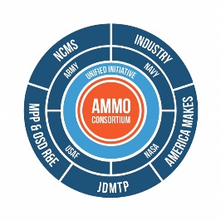

Additive Manufacturing Maintenance Operations (AMMO)

NCMS/CTMA/NSWC Corona Letter of Intent to Submit American Makes Proposal, Project Call Number 3
John Wilczynski
America Makes Deputy Director, Technology Development
Nation Center for Defense Manufacturing and machining
John.wilczynski@ncdmm.org

Project Title: Evaluation of Additive Manufacturing Measurement Uncertainty
Lead Applicant: NCMS/CTMA/NSWC Corona
Project Focal Area: Additive Manufacturing Process
Project Focus: Project will focus on the reliability of the Test, Measurement, and Diagnostic Equipment (TMDE) embedded in AM equipment to ensure the hardware is performing as specified by the OEM through calibration and an unbroken chain of traceability to national standards. Improving the AM Process performance may reduce the verification time required for artifacts after the job is completed. Measurement parameters will be identified and tested to establish maximum measurement deviations and errors. The effects of measurement errors and uncertainty may be seen when measuring items like temperature gradients and laser power fluctuations.
Benefit to Industry / Impact to Industrial Base: By ensuring that AM equipment, sub-system TMDE, is functioning as specified by the OEM, the requirements to verify each component’s accuracy may be reduced to periodic inspection. Increasing the reliability of AM systems will reduce the turnaround time from concept to production artifacts transitioned into use. Establishing a calibration procedure for AM systems may improve the performance and reduce the probability of misprints.

Benefit to DoD: Provide the warfighter with reliable additive manufacturing equipment for both critical and non-critical applications. Incorporating the Metrology and Calibration (METCAL) program will help identify and mitigate the risks of component and system drift. Increasing the reliability of AM systems may lead to reduced downtime for the warfighter and may increase the readiness level.
Project Participants:
- Naval Service Warfare Center Corona Division
- National Center for Manufacturing Sciences
- Industry

