March 25, 2015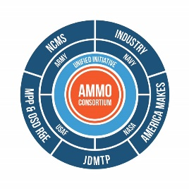

NCMS/CTMA Letter of Intent to Submit American Makes Proposal, Project Call Number 3
John Wilczynski
America Makes Deputy Director, Technology Development
Nation Center for Defense Manufacturing and machining
John.wilczynski@ncdmm.org

Project Title: NDTE Inspection and Testing for Validation of LENS Repairs
Lead Applicant: NCMS/CTMA
Project Focal Area: Additive Manufacturing Process
Project Focus: The LENS process is a recognized repair process utilized by AMC. Our proposal will deal with maintenance operations use of NDTE processes for inspection and the necessary testing to validate LENS for repair and generation of necessary repair change authorizations.

Benefit to DoD: This validation step is necessary to modernization of the Army’s manufacturing and engineering development practices while improving efficiencies and readiness, increasing availability of DoD weapons systems, accelerate depot turn- around times, and provide cost saving returns over the remanufacturing or part replacement methods in use today when a LENS repair solution is denied.

Participants:

ARDEC

TARDEC

Anniston Army AD

NCMS RARE Parts team members

