March 25 2015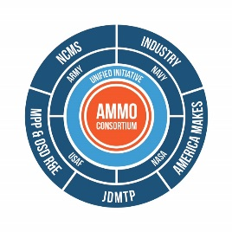

Additive Manufacturing Maintenance Operations

NCMS/CTMA Letter of Intent to Submit American Makes Proposal, Project Call Number 3

John Wilczynski
America Makes Deputy Director, Technology Development
Nation Center for Defense Manufacturing and machining
John.wilczynski@ncdmm.org

Project Title: Accelerating the Use of Casting Tooling and Molds via AM in DoD Maintenance and Sustainment
Lead Applicant: NCMS/CTMA
Project Focal Area: Additive Manufacturing Value Chain
Project Focus: Project will produce process change improvements in end-to-end value chain cost and time to integrate AM produced molds, patterns, and tooling in the production of DMSMS cast parts within the maintenance and sustainment communities and DLA.
Benefit to Industry / Impact to Industrial Base: Digital files used in the production of castings by U.S. based casting houses must become the norm in order to restore the competitive prominence of our industrial base. As DoD increases its usage of AM based molds, patterns, and tools in its acquisition and production of cast parts, its supply chain of U.S. based casting houses will respond accordingly.

Benefit to DoD: Acceleration of usage of AM by DoD in its acquisition and production of DMSMS cast parts through procurement and engineering process changes will increase availability of DoD weapons systems, accelerate depot turn- around times, and provide cost saving returns over the inefficient and costly remanufacturing methods in use today when an essential casting is no longer available or attainable.

Project Participants:
- Fleet Readiness Center Southeast
- Naval Foundry and Propeller Center
- American Metalcasting Consortium (AMC) member(s)
- Defense Logistics Agency, Richmond
- Defense Logistics Agency, Headquarters New Cumberland
- Industry - TBD

