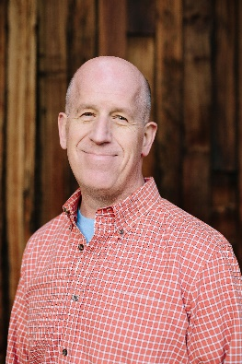
Presenter Information
Dr. Robert Yancey
Director Business Development
Hexcel
385-215-5451
robert.yancey@hexcel.com
Experience/Company Background with Advanced Composite Materials
Hexcel is a global leader in advanced composites technology. Dr. Robert Yancey currently leads business development for Hexcel in the Americas which includes advanced materials, manufacturing, and engineered products. He has a technical background in composite materials, composite mechanics and micromechanics, design optimization, additive manufacturing, finite element modeling, and nondestructive evaluation. He holds a B.S. degree in Aeronautics and Astronautics from MIT, an M.S. degree in Engineering Mechanics from Virginia Tech, and a Ph.D. in Materials Engineering from the University of Dayton. He is an AIAA Associate Technical Fellow and Composites Factory of the Future Lead for SAMPE.
Title
Additively Manufactured Carbon Fiber PEKK
Presentation Description
This presentation is a discussion of the challenges of transitioning additive manufacturing (3D printing) from a prototyping technology to a flight-worthy, production-ready technology. The demanding quality and material performance requirements of aerospace set a high bar for qualifying additively manufactured components. For additive parts to fly they also need to compete on the same merits as traditional manufacturing methods: cost, weight and lead time. Hexcel’s HexPEKK® material, which is a high-performance polymer/carbon blend processed with selective laser sintering, meets that high bar. This presentation introduces the HexPEKK® material and how Hexcel’s integrated manufacturing lends itself to use on defense, space, and commercial aviation applications.

